ASSIGNMENT – 38

CREATING LOGGING RECORDS AUTOMATICALLY

Table creation:

CREATE TABLE log_table (user_id VARCHAR2(30), logon_date DATE);

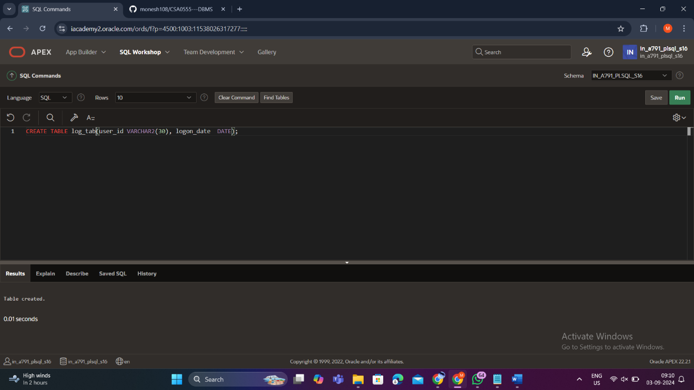

CREATE OR REPLACE TRIGGER log_sal_change_trigg1

AFTER UPDATE OF DEP_NAME ON DEPARTMENT

BEGIN

INSERT INTO log_tab(user_id, logon_date)

VALUES (USER, SYSDATE);

END;

/

DISPLAY:

UPDATE DEPARTMENT SET DEP_NAME='ECE' WHERE DEP_NAME='CSE';

OUTPUT:

Select * from log_table;